EXTERNAL AGENCY CLIENT REFERRAL FORM

Date of referral:

CLIENT:
Name of Client:
Date of Birth: | DOB: Age:
Address:
Sex: | Male / Female
Contact details: | Home: | Email:
Ethnicity: |  | Cell:
Iwi:
Occupation:

PARENT/CARE GIVER/FAMILY INFORMATION (if appropriate):
Name:
Is the family aware of this referral? | Yes / No | (Comments, if appropriate):
Address:
Contact details: | Home: Email: Cell:
Relation to client:
Details of family members: Name: | DOB: |  | Age: | Gender:

HOW DID YOU HEAR ABOUT THE SOWERS TRUST:

REFERRAL DETAILS:
Organisation:
Address:
Workers name:
Contact details: | DDI: Fax: Cell:
Email:

SERVICES CURRENTLY SUPPORTING THE WHANAU:
Please specify and give brief summary:
Please highlight services that may be helpful to you | Parenting Social work  Youth Mentoring Sow and Grow  Waves (bereaved by Suicide)

Is Oranga Tamariki involved with this whanau? | YES NO
Are you aware of any Police involvement? | YES NO

BRIEF HISTORY AND ANY EXPECTATIONS OF THE SOWERS TRUST:

PLEASE TICK THE BOX IF IT IS OK TO TAKE PHOTOS/VIDEOS TO BE USED FOR PROMOTIONAL REASONS

This consent form sets out the choices you have when you engage with Sowers.

Privacy Statement for Collection of Personal Information
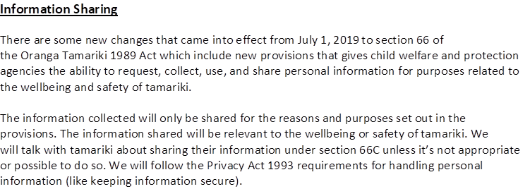
Sowers trust is funded by Oranga Tamariki to provide support to young people and whanau.
I understand and agree that:
1. Information may be shared with the agencies that are also working with me.
2. I can decide to decline support from Sowers at any time.
3. Information about my whānau/family’s will be used for statistical purposes, but only information that does not identify any member of my family/whānau.
5. The Sowers Trust worker has explained the complaints process to me.
6. Agencies will only share my information with other agencies involved in this case. They will follow their agency’s confidentiality code.
7. My family/whānau can choose to bring support people to meetings.
8. I can make suggestions about the meeting venue, cultural protocol to follow at the meeting, and any other needs I may have, such as translators, disability access, etc.
9. I understand how my whānau/family’s personal information may be used.
10. I am entitled to a copy of this consent form

I consent to transport myself or tamaraki under my care (if minor) in vehicle provided by Sowers if required (Please tick if consenting)

I consent to obtain medical assistance if required (Please tick if consenting)

Client Signature: ________________________________________________ Date: ____________________________
If you would like to discuss a referral, arrange a visit or require any further information, please contact our referral coordinator on 09 5380050 or referrals@hcc.co.nz.

ADDRESS:
The Sowers Trust www.thesowerstrust.com
The Picton Centre, 09 5380050
120 Picton St, PO Box 38360
Howick, Auckland, 2014 Howick, Auckland, 2014

